DEVELOPER GUIDE

EarthScape_ClimateAgency



Prepared By : Kaarim Hussain
Asim Sarfaraz
Muhammad Arham khan
Ubaidullah Iqbal
Sundus Khalid Khan
Laiba Ali

Faculty: Sir Owais Khan

app/feedback
page.tsx
Feedback refers to the information or response given about someone's performance, behavior, or work, intended to guide improvement, reinfworce good practices, or adjust actions.

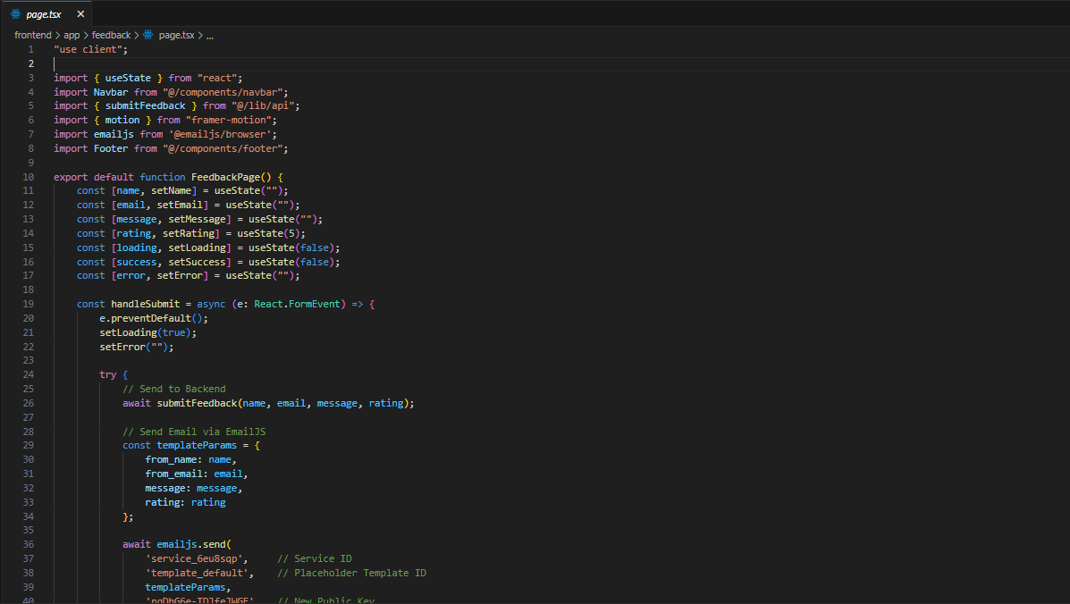

layout.tsx
The root entry point of the project of next js!
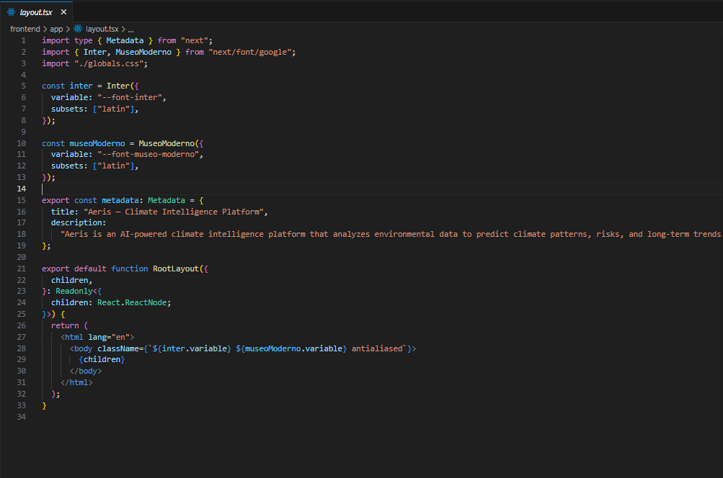

auth/login/page.tsx
Authentication system using JWT and next js backend
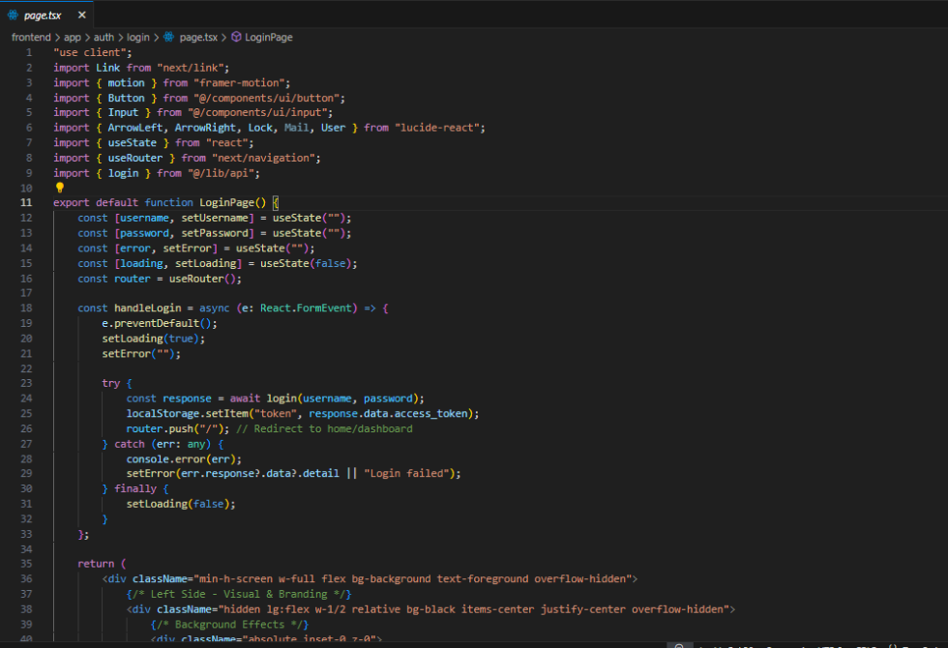

Notification Page.tsx
A realtime notification is a message or alert that provides information, a reminder, or a warning about something that has happened or will happen.
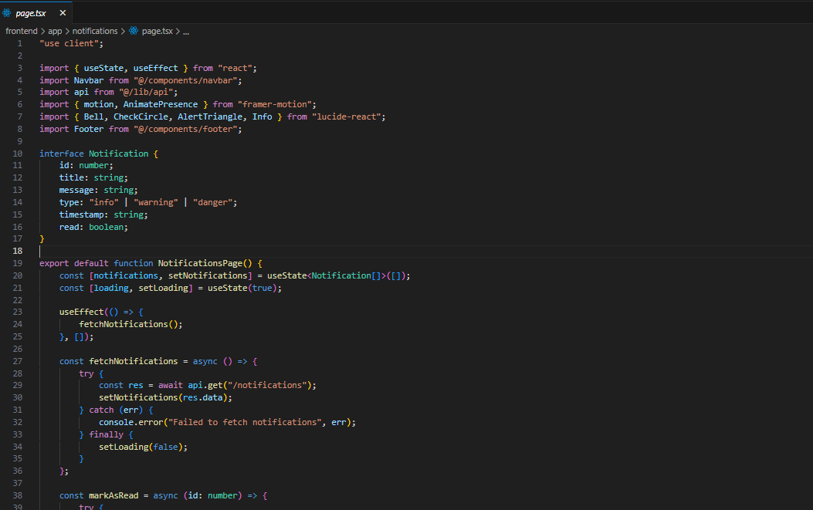
Predict.tsx
In Hadoop, the term "predict" typically refers to making future estimations or classifications using data processing and machine learning models built on top of Hadoop's big data framework .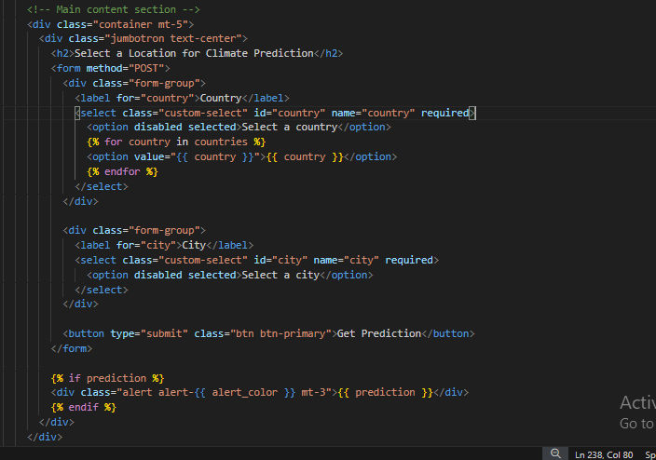
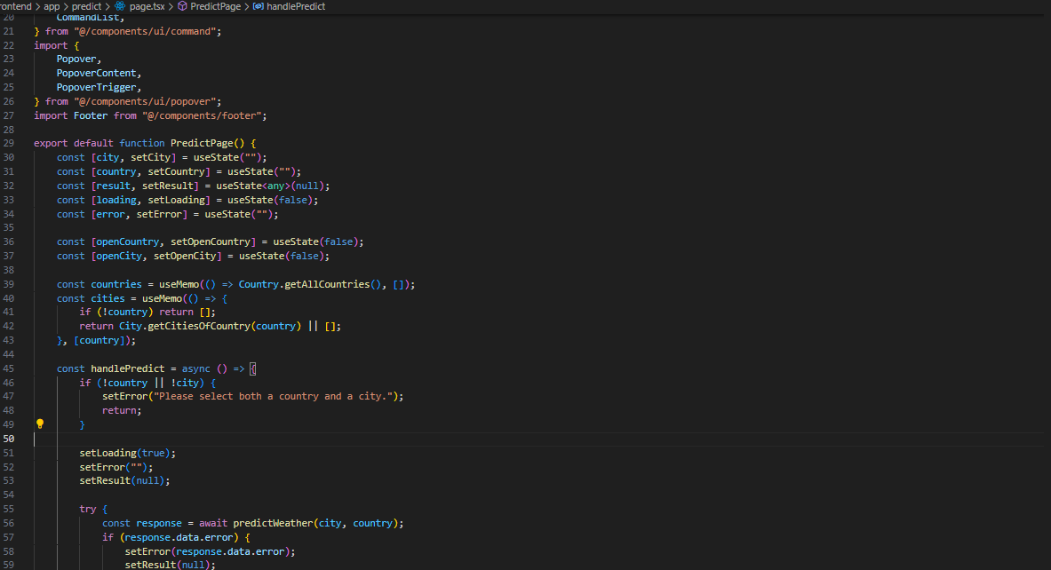

Register.tsx
In most cases, register refers to the act of recording an event, transaction, name, or other information, or an aggregation of stored data, usually containing past events, transactions, names or other information.

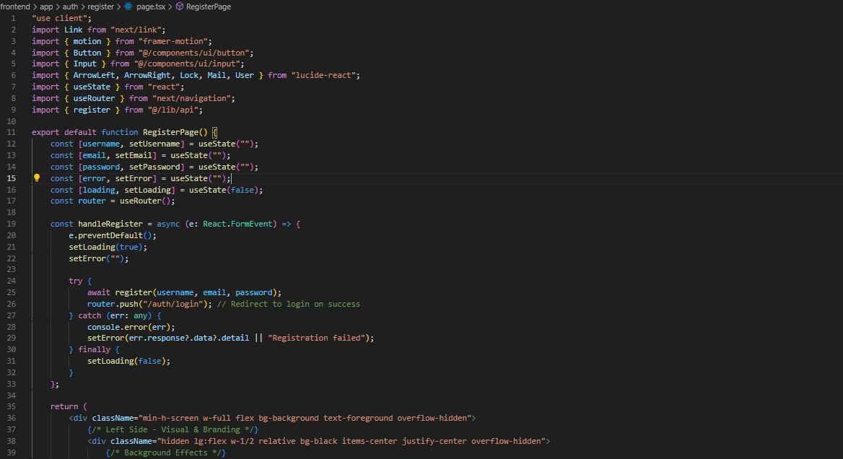

Visualization.html
In the context of Hadoop, visualization refers to the graphical representation of large datasets processed and stored within Hadoop's ecosystem. Since Hadoop deals with vast amounts of distributed data, visualization helps in analyzing and interpreting complex data in an intuitive and interactive way.
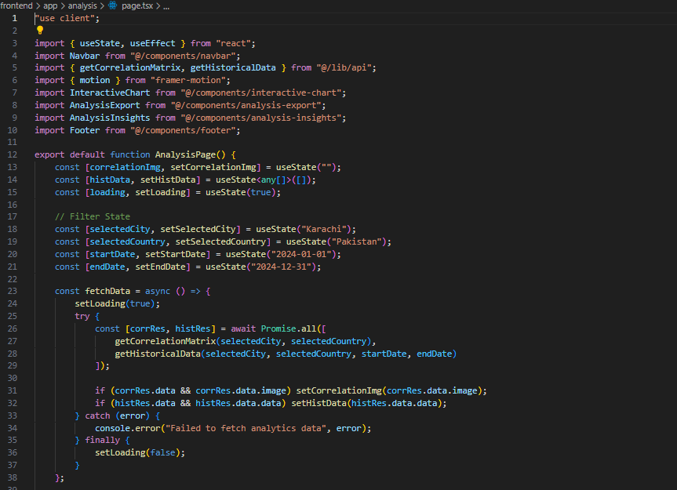

.

App(_main.py)
This file indicates that the App directory is a Python package. It allows the package and its modules to be imported and used elsewhere in the project. the environment for the package to run properly.

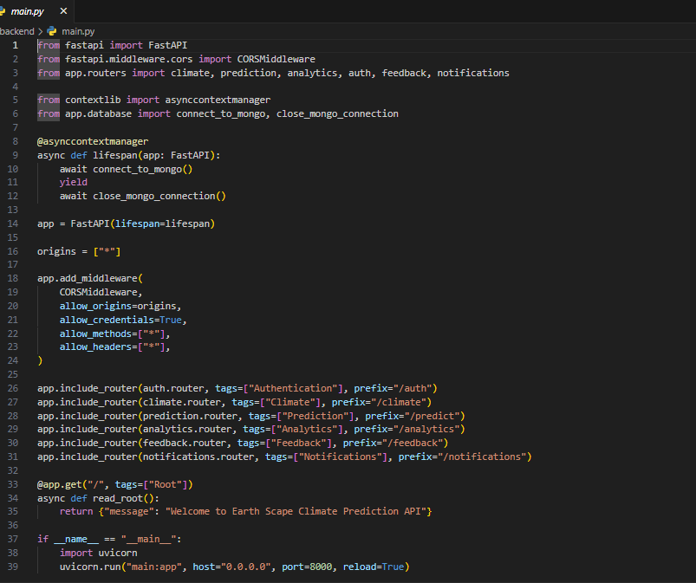

(security.py)/Auth.py
Auth.py is a Python file that typically handles authentication and authorization in a web application. It contains functions and logic to manage user-related actions like logging in, signing up, logging out, and protecting routes.

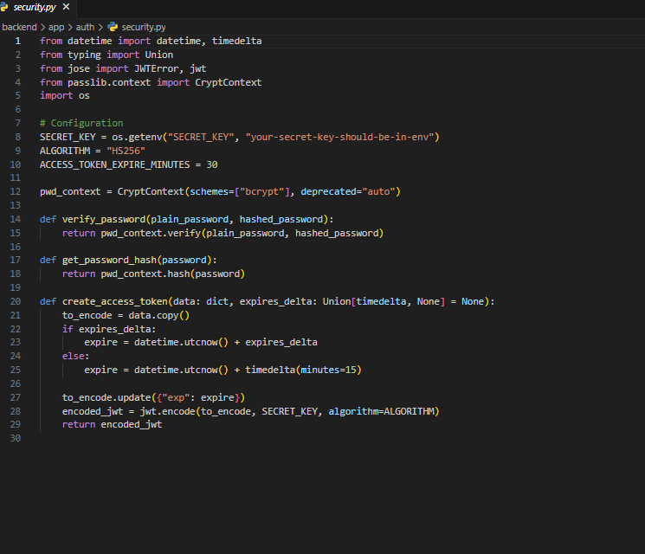
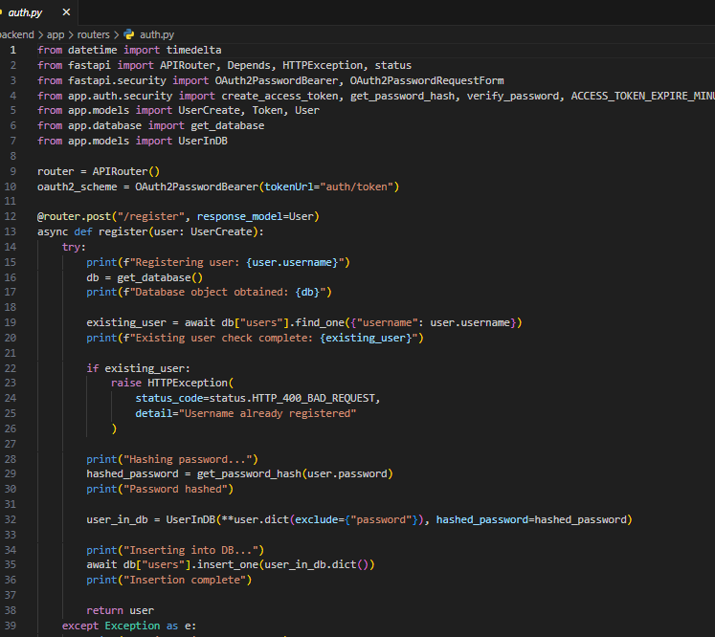
Ml Services.py
A typical data_ingestion.py script is used to handle the process of ingesting data from various sources into a system for further processing, analysis, or storage. It often includes the following functionalities.
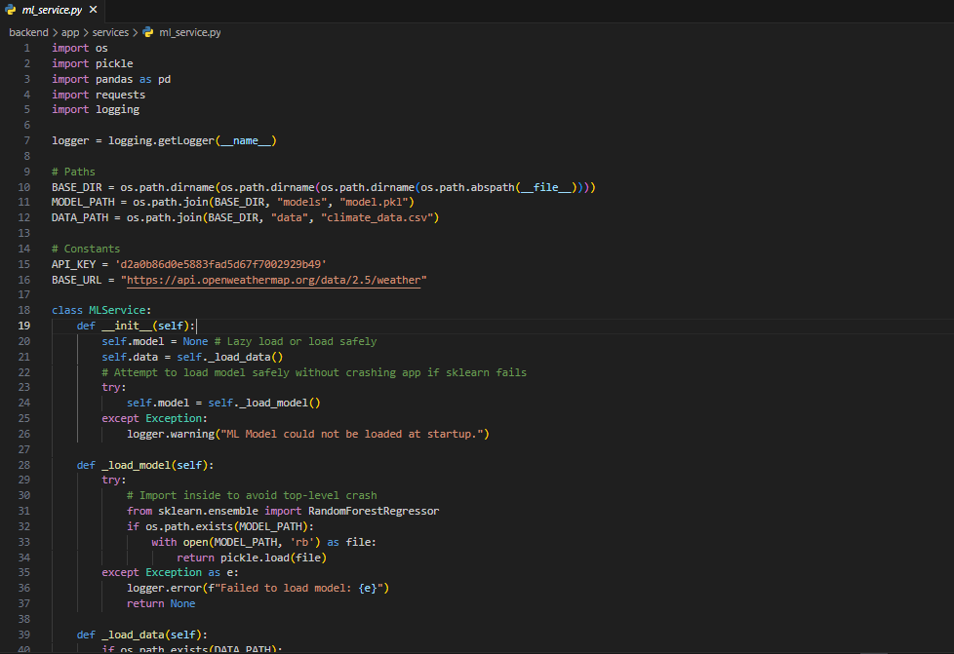

feedback.py
A feedback.py file is typically used in Python projects to handle the collection, processing, or storage of feedback data. Depending on the specific use case, it might include functions to:
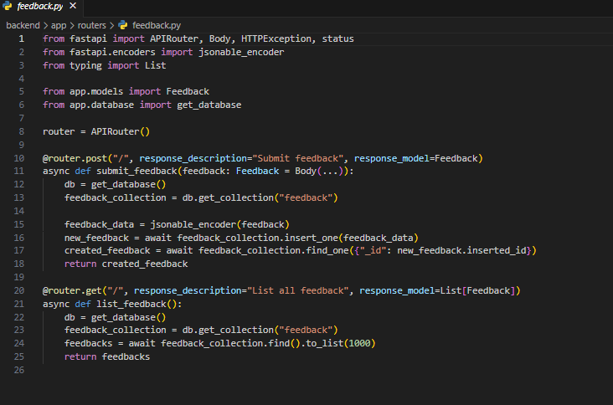
Main.py
The main.py file serves as the entry point for the Python application. It typically contains the primary logic that initiates the program. Depending on the project, this file may include the following components:

Ml_model.py
A Ml_model.py file usually contains the necessary code to define, train, evaluate, and save a machine learning model. Below is a breakdown of the sections you typically find in such a file:
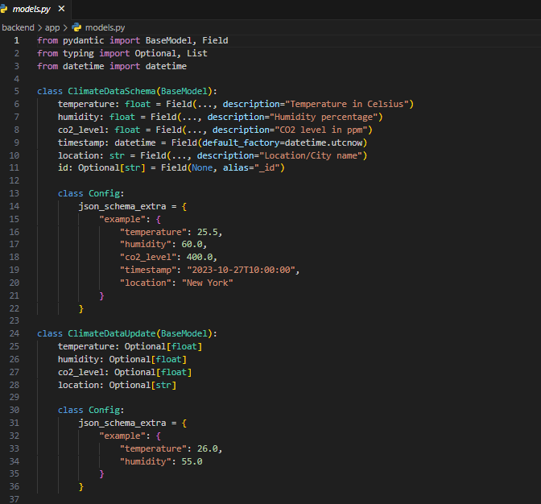

Models.py
In Django, models.py is a Python file that is used to define the models for the application. Models in Django represent the structure of your database tables and contain the logic for interacting with the database.


Notifications.py
Notifications.py is a Python module responsible for handling notifications within an application or system. It is typically used to alert users or administrators about important events, actions, or system updates.
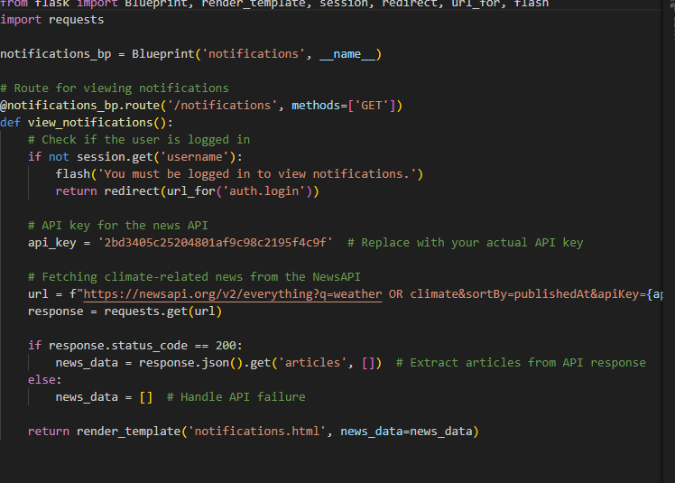

.

Visualizations Analytics.py
The analyatics_services.py file is typically used in data science or analytics projects to hold all the code related to visualizing data. It helps convert raw data into visual formats like graphs and charts, making the data easier to understand and analyze.
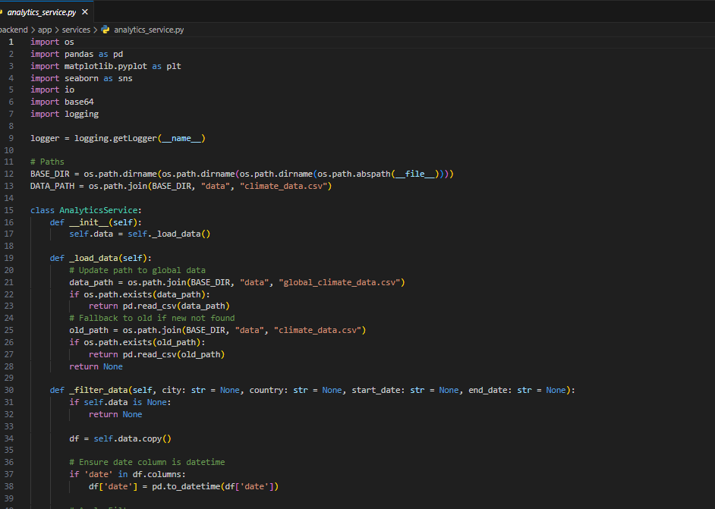
Climate.py
In Hadoop, Configuration (or config) refers to the settings that control how Hadoop services and applications behave. It is a core part of how Hadoop is set up and managed.in climate.py
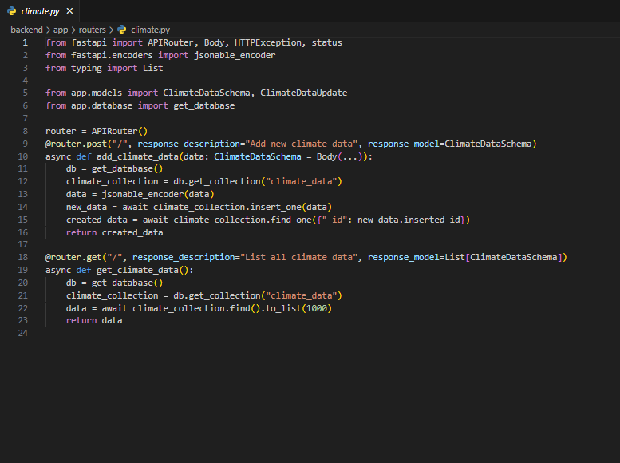

Key Features:
- It helps keep secrets and configuration separate from your source code.
- Commonly used in development environments with frameworks like Node.js, Python, Django, etc.
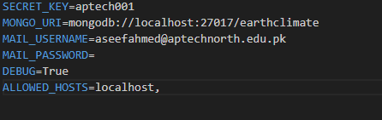

Static
Styles.css
A style.css file is used to define the visual appearance and layout of a website or web page.

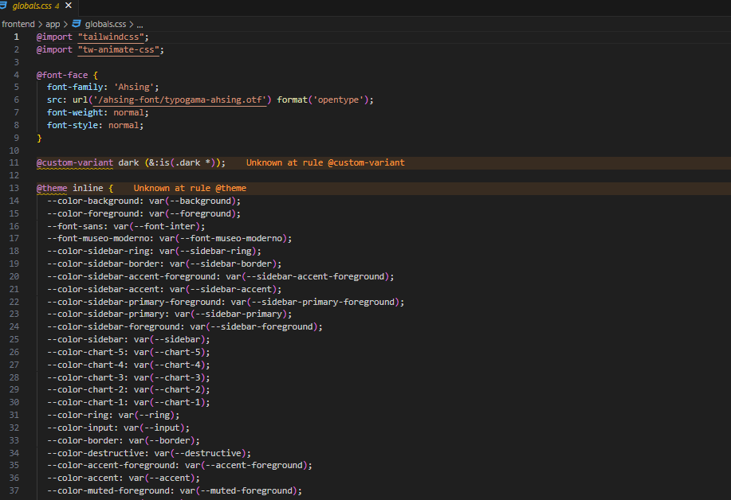

README.md
The README file provides a basic overview of the project, including its purpose, setup instructions, dependencies, and other important information. It serves as a helpful resource for users and developers to understand and use your project.

